A-Team Tutorials

1.1 Targets and Priorities

What to Observe?
Which object should you select for a measurement? Of course, this will depend on your own interests for example:
- Easy asteroids or comets to practice using Astrometrica.
- Asteroids for which the Minor Planet Center (MPC) or European Space Agency (ESA) require measurements.
- Recent discoveries not yet confirmed.
- Recovery of objects that have not been seen for a long time.
If you are new to asteroid chasing then it may be best to start with some bright, slow-moving, easy ones and these can be found at the “What’s Observable” website or using your own planetarium software.
If you are already experienced at using observing lists from the MPC or Lovell Observatory, then you may refer to them but select some reasonably bright targets that can be used to practice Astrometrica.

What’s Observable?
The easiest place to find what’s observable tonight is the What’s Observable? website. Go to the site and set up the search:
- Edit Observer Location to a Slooh observatory code. Press Edit, put G40 (Canaries) or W88 (Chile) in the Lookup the Specified Location box and press Search.
- Change the Observation time to a time when you believe there will be some free mission slots at your chosen telescope. This does not have to be precise, any time around the middle of the night will be OK.
- Set the Min elevation angle to 40 degrees to ensure you will have a good view of the objects.
- Move the slider next to Visual Magnitude and enter 13 – 17. That will give you a list of objects that are a reasonable brightness for this exercise.
- You can usually leave the rest of the constraints to the default.
- Select “Retrieve Data” (it may take some time).

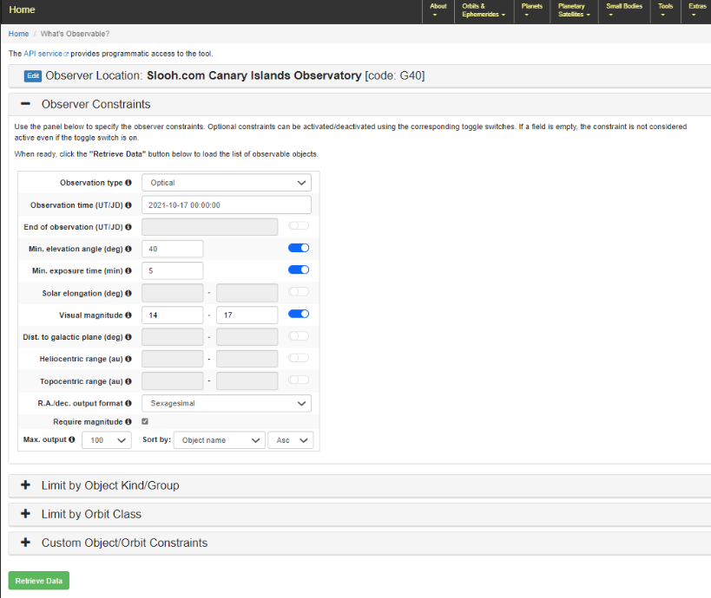
Set up What’s Observable? query.
You will get a list of objects like this:
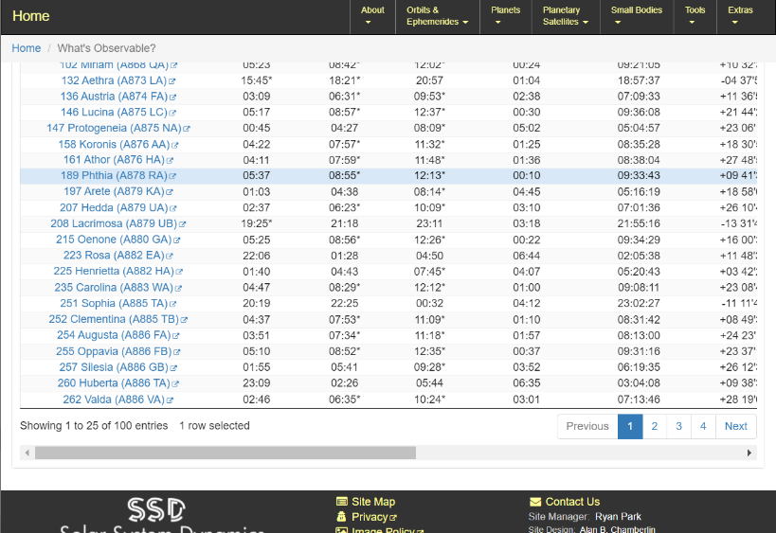
List of objects
The list will contain lots of objects visible from your chosen observatory. Look for some that have convenient rise/set times.
- Check the Object-Earth-Moon angle (deg). This tells you how far away from the Moon the object will be in the sky. It’s best to go for objects that are at least 60 degrees away from the Moon otherwise stray light from the Moon can ruin your images.
You can see lots of technical details about an object by clicking on its name.
Select a few of the objects you might be interested in (it probably does not matter which ones as long as they are well away from the Moon) and make a note of their names and numbers.

Planetarium software
You will sometimes need to use planetarium software to display star (and asteroid) maps. There are lots of commercial and free packages available and you may already have your own favourite. Make sure you are familiar with the functions to download asteroid data, filter asteroids by magnitude and display them on the map.
(I am currently using C2A because of its flexible handling of comets and asteroids – and it’s free!)
A star map showing asteroids can be a convenient way of selecting interesting observation targets. Set up the map for a time near the availability of Slooh missions and with Mt. Teide or Santiago Chile as the observatory location.
Filter your asteroid database to magnitudes 13 to 17. Examine the map for objects that are not too near the horizon and not too near the Moon.
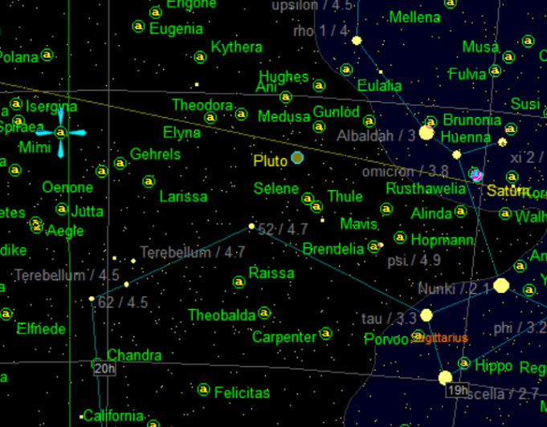
Asteroids in a C2A chart.

A-Team Suggestions
Other members of the A-Team are constantly trawling various sources of data and will be happy to propose a target to give you a challenge appropriate to your skill level and there is a simplified list at A-Team Targets.

Priority
Later in the programme it will be important to review the priority of each of the candidates at the Minor Planet Centre (MPC) and Near-Earth Object Coordination Centre (NEOCC). This will tell you whether observations of the objects are currently required.
However, at Level 1, it is more important to select something that will give you a good chance to practice data reduction and measurement in Astrometrica. This means selecting an object that is well within the capabilities of the telescope in terms of magnitude and speed.
The final decision on which object to go for will be made after you have checked its coordinates and some other information.
Originally published April 2014. Last updated 22 Mar 2024.
Tony Evans

